Sport collocations

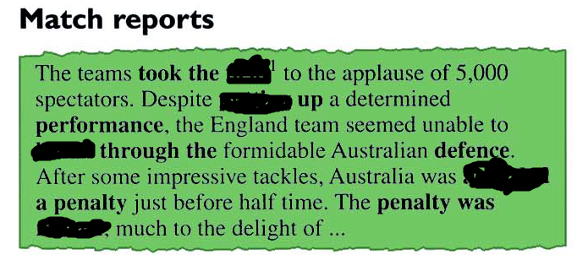

awarded, field, putting, break , missed

field, putting, break, awarded, missed

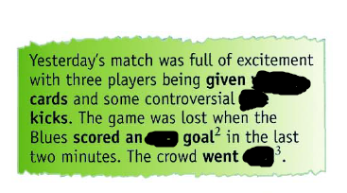

own, yellow, free, wild

yellow, free, own, wild

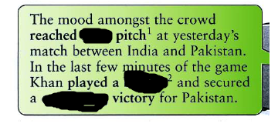

fever, blinder, convincing

fever, blinder, convincing